Guide to Using the ADA-Compliant Word Template
Contents
Guide to Using the ADA-Compliant Word Template 1
Settings 2
Software 2
Accessibility Checker 2
Permissions 2
Document Structure 2
Title and Overview 2
One Action = One Step for Instruction Guides 3
Styles 3
Headings 4
Paragraphs/Normal Text 4
Lists 4
Table of Contents 5
Headers and Footers 5
Spacing 5
Metadata 6
Content Elements 6
Tables 6
Hyperlinks 7
Link to Webpage 8
Link to Send Email 8
Link to Heading within Document 8
Images and Objects 8
Notes Boxes 9
Alternative Text 10

Use these instructions when creating a document using the Training & Organizational Development ADA Instruction Guide template. This will ensure you are following the ADA guidelines when creating your documents.

Settings

Software
- Ensure you are using the latest version of Office 365 Professional.
- Edit documents by opening them in Word Desktop app instead of in Teams or Browser.

Accessibility Checker
- Use Word’s built-in Accessibility Checker. While this checker is not exhaustive, it will catch some basic issues.
- To locate the checker, go to Review > Check Accessibility or select the Accessibility icon at the bottom right of the screen.

Permissions
- Set to open in read-only by default.

Document Structure

Title and Overview
- Position at the top of the page under header: Verb + Subject (e.g., “Request a Catalog Change”).
- Use the Heading 1 style for the title.
- Overview should include the following:
  - What this guide is…
  - What this guide is NOT…
  - Required security roles and training for this action
  - Navigation to [URL address]
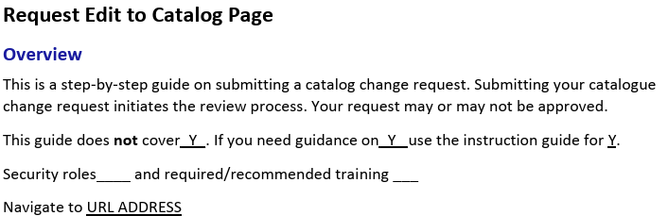

One Action = One Step for Instruction Guides
- Separate out each step in a process.
- Even small steps such as “Continue” and “Submit Request” should be separate.
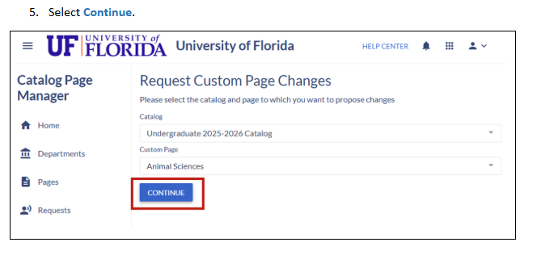
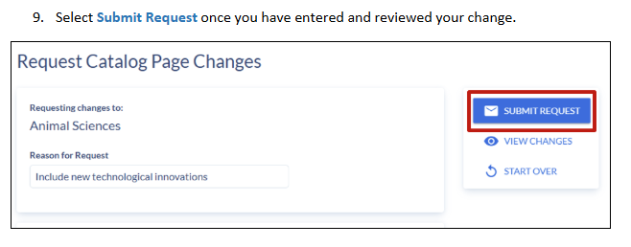

Styles
Styles are the most important component of an accessible document. All text in the document must be assigned a function using Styles.
- Locate the styles menu, by selecting Home Tab > Styles.
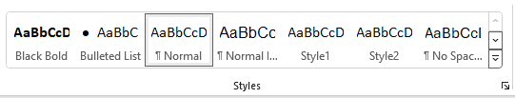
- Headers: set automatically (Header 1 = #000000; Header 2 = #0021A5)
- Strong
  - Use for notes and occasional emphasis
  - Black (#000000) and bold
- Click
  - Apply this style to any text selected or clicked on
  - Includes section, button, drop-down menu, link, as well as anything with “Confirm,” “Continue,” etc.
  - Blue (#1C78BB) and bold
- All other text should be “Normal” style.

Headings
Use built-in Heading styles Heading 1 for the title and Heading 2 for each section thereafter. This establishes an easier way for screen readers to navigate to desired content.
- When naming the title of the steps in a process for an instruction guide, use “How to [Name of IG].”
- Ensure logical heading order (e.g., Heading 2 > Heading 3).
- Do not skip heading levels, such as using a Heading 4 after a Heading 2 with no Heading 3 between the two.
- Be consistent in using the same heading style for each section.
- Limit to the first six Headings, use Headings 5 and 6 sparingly.

Paragraphs/Normal Text
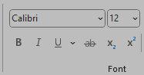
- Use the colors that are embedded in the styles for normal text and headings.
- Avoid highlighting.
- Set all text to Calibri. Use 12-point for body text, 16-point for Heading 1, and 14-point for Heading 2 and all subsequent headings.
- Avoid manually formatting text with bold, italic, or font changes.
  - Use Styles: Strong, Emphasis and Intense Emphasis.

Lists
Use the list tools in the Paragraph section to create numbered or bulleted lists.
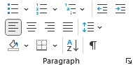
- Both numbered and bulleted lists default to the List style.
- Use numbers for sequential steps. Any step-by-step process should be numbered.
- Use bullets for guidance outside of a step-by-step process.
  - Use the standard circle bullet.
  - Use the open circle for sub-bullets.
  - Avoid using symbols like hyphens or asterisks to simulate lists.

Table of Contents
Proper utilization of the Words Styles will enable users to generate a responsive Table of Contents for documents more than 3 pages.
- Create a table of contents, by selecting References > Table of Contents > Automatic Table 1 or 2.
- To update changes, select Update Table.
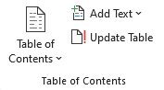

Headers and Footers
Headers and footers should follow the new format.
- Headers: use the T&OD image shown below
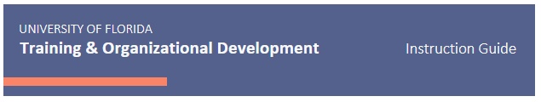
- Footers should include the following:
  - Department | Unit
  - Title of Instruction Guide (same title as the top of document)


Spacing
- Zero space between title and first step.
- Zero space between step and screenshot.
- One space between previous screenshot and next step.
- Do not add extra spaces to push the step and image to the next page. The step and the screenshot will often be on separate pages.
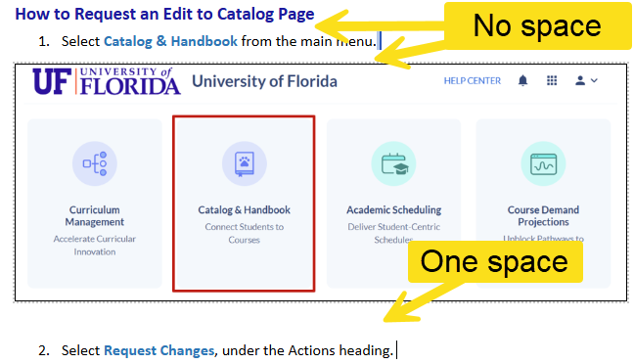

Metadata
- Enter metadata for your document by going to File > Info > Properties > Title.
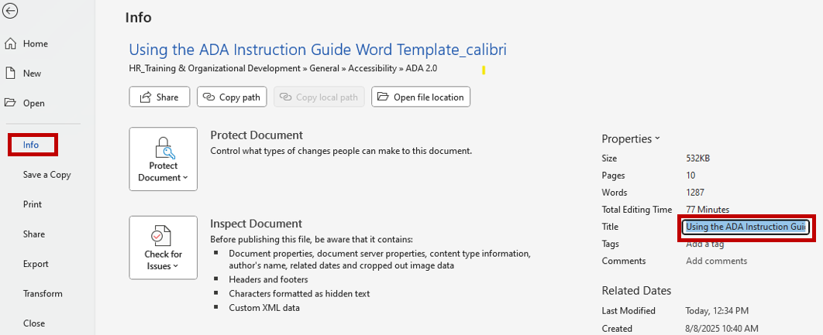
- Use the same title as what is designated as the Style Heading 1 of your document. This should also be your file name for Z drive organization.
- Include the title in the footer.

Content Elements

Tables
- Use Insert > Table to add a new table.
- Go to Table Design > Table Style Options (upper left).
- Select the check box for header row, banded rows, and first column.
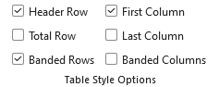
- Select the Table > Table Layout > Table > Properties > Row.
  - Uncheck Allow row to break across pages.
  - Check Repeat as header row at the top of each page
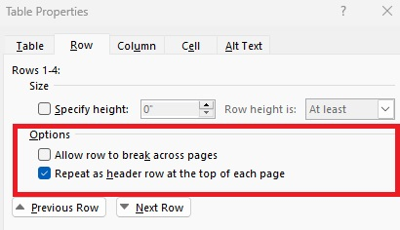
- Highlight the top row of your table.
  - Select the Table Layout tab at the top.
  - Select Repeat as header row.
- Add a table of caption in the References > Insert Caption.
  - Label should be set to Table. Select OK.
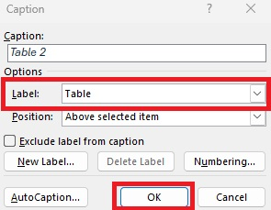
- Include a title and headers for your table.
- Add Alt text for the table (alt text instructions).
- Use a caption under the table, if needed.
- Avoid bulleted lists, empty spaces, and merged or split cells.

Hyperlinks
Link webpages, emails, navigation to headings or bookmarks within the same Word document.

Link to Webpage
- To create a hyperlink, highlight the text, right click, select Link and enter web address in the space beside address.
- Use descriptive link text (e.g., “Visit UF Accessibility Resources” rather than “Click Here” or “Read More”).

Link to Send Email
- To create a hyperlink, highlight the text, right click, select Link and enter the mailto: email address in the space beside address.
- Use descriptive link text (e.g., “Email Training support” rather than “send email”).

Link to Heading within Document
- To create a hyperlink, highlight the text, right click, select Link > Place in This Document and then select Heading.
- Use descriptive link text (e.g., “Navigate to guidance on using heading styles” rather than “jump here”).

Images and Objects
- For all images, right click image > Wrap Text > In-Line with Text.
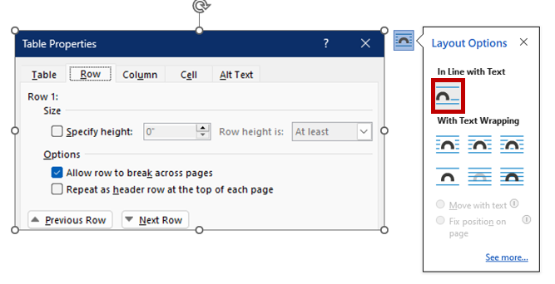
- General appearance of images for screenshots.
- First screenshot: typically an image of the entire screen to orient readers.
  - Subsequent screenshots: image may exclude the elements on the web page such as the header (top bar) or other elements that are unrelated to the current step in the guide.
  - Border: solid, black, .75 width
  - Boxes: 2 ¼ pt, red (#C00000)
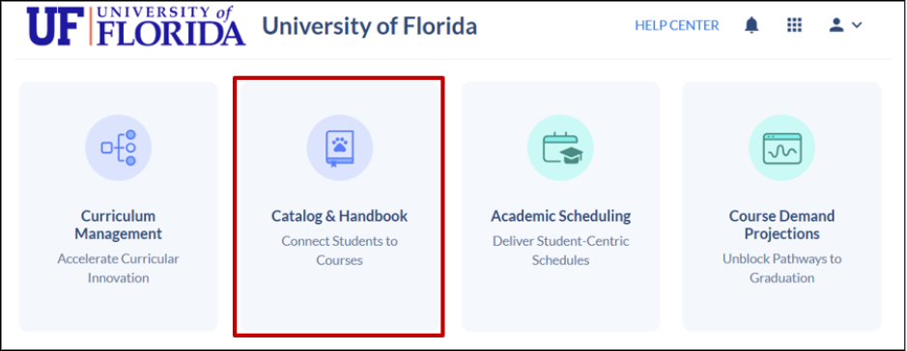

Notes Boxes
Notes are used to call out important information.

Note: Notes should not be an actual step in the step-by-step process. Instead, Notes are
special tips or red flags. Use “Note” for helpful guidance and “Warning” for statements of
caution.

Warning: Use the Word app for editing. Web-view often causes errors related to
formatting.

- Highlight the text you want a box around
- Set the “Note” style on the paragraph.
- Select the first word (usually “Note”) and set it to style “Strong.”

Alternative Text
Add alt text for all meaningful images and screen shots. This includes images, charts, tables, and diagrams in your document.
- To add alt text, right click the Image > View Alt Text.
- Enter alt text in the space provided using the best practices below.
- Best Practices for Alt Text
  - Provide context which explains why the image is significant.
  - Be descriptive, but not too wordy.
  - Avoid saying “picture of…” or “screen shot of…”
  - Describe the image more than just saying what it is. Give context.
  - For charts, provide succinct alt text plus a table or lengthier text alternative near the image.
  - For more complex images, visit W3C Complex Images resource.
  - Select Mark as decorative if the image, such as a pretty banner, does not have informational significance.
  - Avoid using the auto-generated alt text in Microsoft 365.
  - Examples of alt text:
    - "An orange box emphasizing the 'activity manager' section within the activities tab of the faculty insight dashboard."
    - "Activity Manager panel highlighted in the Faculty Insight Activities tab.”
